TITLE OF ABSTRACT
A.B. Presenting Author¹, C. Co-author¹, D.E. Co-author²
¹University, Country; ²Affiliation 2
e-mail address of the presenting author
The abstract should be formatted using the template provided and must be submitted online. This is the abstract sample. Text of your abstract should be submitted in Microsoft Word (2007 or later version) format. Abstracts will be included in the Conference materials.
Paper size: A4. Margins: 2.5 cm on the top and bottom, 2.0 cm on the right and left sides.
Font: Times New Roman, 12 pt; line spacing: single; no extra spacing between paragraphs.
Abstract size: no more than one page including tables and illustrations, if any.
The document should include the following items in the specified order only: Abstract Title, Authors & Affiliations, Abstract main text.
The abstract title must contain no more than 200 characters, including spaces.
For each affiliation the name of the university or main organization and the state should be indicated. Full street addresses should not be included. The presenting author's email address may be included on the next line.
No header or footer is allowed.
Inclusion of embedded figures is accepted. Figures should be of good quality and sufficiently high resolution (not less than 300 dpi). Figures should be embedded in the main text file. Graphics, including tables, must be located at the end of the abstract, just before references. Graphics, including tables, should be maximum 17 cm wide. Do not wrap the text around any of the graphics. Graphics, including tables, must have captions.
Acknowledgements, if necessary, must be located at the end of the abstract, just before the graphics and references.
The total file size should not exceed 5 MB.
Acknowledgements The financial support of …
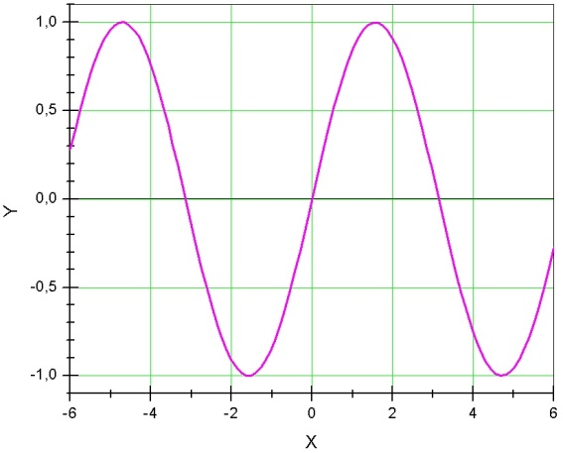
Figure 1. Figure caption.
[1] A. Name, B. Name and C. Name, Journal Title, 2000, 35, 3523.
[2] A. Name, B. Name and C. Name, Journal Title, 2005, 40, 5432.
[3] A. Name (or Editor), Title of the book, 2000, Chapter, page(s). Publisher, City, Country.

