Electron density distribution in the complexes of porphyrazine and tetrathiadiazaporphyrazine with Zn(II), Ni(II), Ca(II) from QTAIM analysis
Ryzhov I.V., Kuzmin I.A., Otlyotov A.A.
Student, 1 year bachelor
Ivanovo state university of chemistry and technology,
Ivanovo, Russia
E–mail: ryzhoff.ihor@yandex.ru
Porphyrazines are characterized by unusual structure and unique properties which underlie their wide applications as highly efficient and selective catalysts, chemosensors, liquid crystals, and photosensitizers. In this regard, the study of the influence of a central metal atom and peripheral substituents on the stability of a complex, π–conjugation system, and charge distribution is an important theoretical problem.
In this work the electronic density distribution in the complexes of porphyrazine (Pz) and tetrathiadiazaporphyrazine (TTDPz) with Zn, Ni and Ca was studied with use of DFT calculations at B3LYP/pcseg-2 level. Wave function analysis was performed in the framework of NBO and QTAIM methods. Laplacian maps demonstrated on Fig. 1 are similar for NiPz and NiTTDPz complexes. NiPz was determined to possess a larger electron delocalization index (δ(A|B) = 0.669) as compared to NiTTDPz (0.643), ZnPz (0.464), ZnTTDPz (0.446), CaPz (0.316) and CaTTDPz (0.298). The charge on metal atom was found to decrease from CaPz (q(Ca) = +1.6 e) to ZnPz (q(Zn) = +1.3 e). The value of q(Ni) in NiPz is remarkably lower (+1.0 e). It can be explained by significantly larger contribution of a covalent component into Ni–N bond (Wiberg bond index is 0.5) as compared to that for Ca–N (0.1) and Zn–N bonds (0.3).
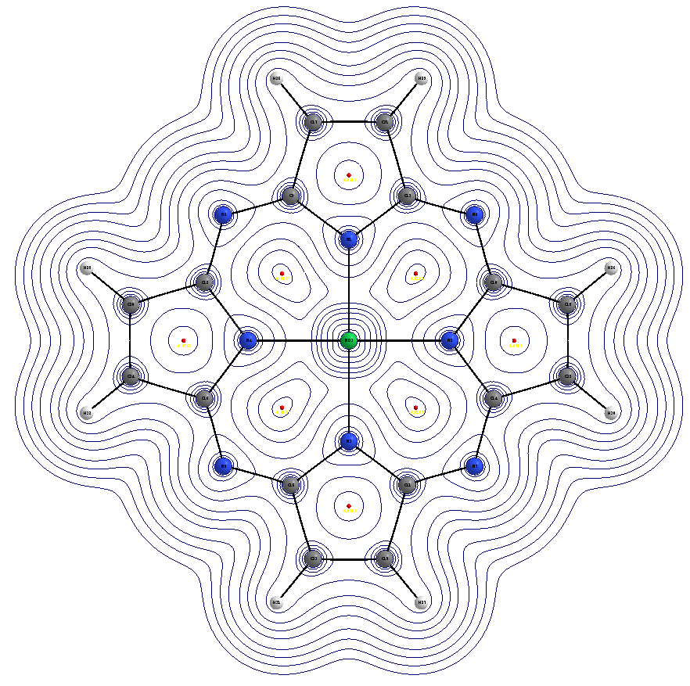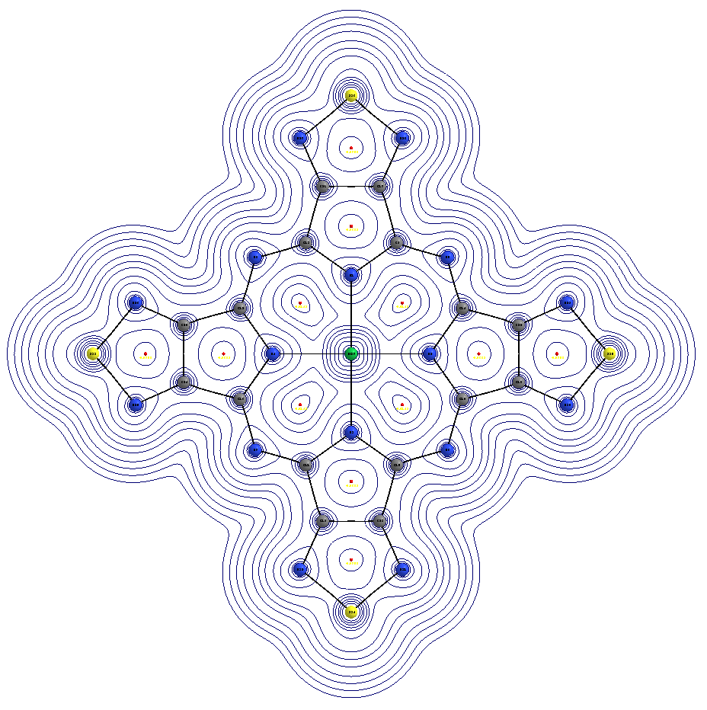

Fig. 1. Laplacian maps for NiPz and NiTTDPz complexes.

Acknowledgement. This work is supported by the Russian Science Foundation (grant № 19-73-00256).

