Features of the titanium dioxide film formation on the surface of an aqueous salt solution as a result of interaction with ammonia vapor
Skvortsova I.
Student, 4th year of undergraduate
Saint Petersburg State University, Saint Petersburg, Russia
E–mail: irina_98nis@outlook.com
Processes of film formation on the surfaces of diverse aqueous solutions take place in nature spontaneously as well as can be initiated in laboratory experiments. The reactions that lead to the formation of these films can proceed by various mechanisms. For instance, well-known films on the surface of tea can be observed due to self-assembly of insoluble impurities [1], while Langmuir films are formed on the surface of the aqueous phase with the participation of surface-active compounds [2]. There are also polycondensation reactions on the surface of the liquid phase which result in the formation of polymer continuous films or membranes [3]. However, formation of solid films as a result of interaction at the interface between reagents from a solution and a gaseous phase is investigated insufficiently.
The object of the study was the surface of an aqueous solution of a titanium salt (TiCl₃, Ti₂(SO4)₃, TiOSO₄, Ti(C₂O₄)₂) which was treated by vapors of gaseous ammonia. The primary source of obtaining visual information about the film formation process was an optical microscope equipped with a digital camera, which allowed video recording at 40-200 times magnification. As a result of the interaction at the interface, the formation of a titanium dioxide film was observed. It was subsequently washed from the excess solution and studied by SEM, optical and IR spectroscopy, XRD, and EDX microanalysis. Afterwards, the influence of several factors on the kinetics of growth and on the morphology of films was researched, including the reagents nature, the concentration and pH of titanium precursors, the concentration of ammonia vapor, the direction and rate of gaseous reagent supply to the surface of the solution.
It was identified that the reaction at the interface between the gaseous reagent and the solution proceeds according to the diffusion-kinetic mechanism with the formation of periodic self-organized structures (Fig. 1 a, b) similar to Liesegang rings that often arise during the precipitation in a gel-like medium [4]. Another feature of film growth is the formation of characteristic folds, the direction of which coincides with the direction of the gaseous reagent diffusion flow (Fig. 1 с). It has been suggested that the presence of these folds empowers film to transform into tubular microstructures with scroll morphology [5].
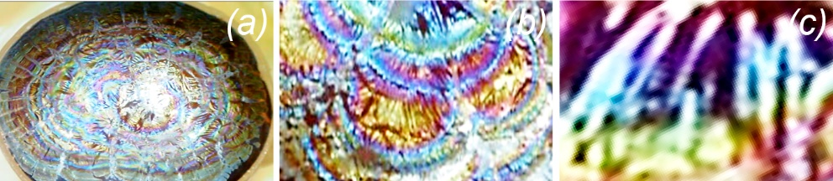
Figure 1. Optical photographs with different magnifications of a titanium dioxide film formed on the surface of an aqueous solution of Ti₂(SO₄)₃ as a result of the interaction with radially fed gaseous NH₃.
This work was supported by the Russian Science Foundation (grant #16-13-10223-P).
References
1. Homsy, A. Laux, E. Jeandupeux, L. et al. Solid on liquid deposition, a review of technological solutions // Microelectronic Engineering. 2015, №141, p. 267-279.
2. Tieke, B. Langmuir–blodgett films for electronic applications // Advance Materials. 1990, №2, p. 222-231.
3. Fendler, J. H. Self-Assembled Nanostructured Materials // Chemistry of Materials. 1996, №8(8), p. 1616-1624.
4. Summ, B. D. Ivanova, N. I. The use of objects and methods of colloid chemistry in nanochemistry // Russian Chemical Reviews. 2000, №69, p. 911-923.
5. Tolstoy, V. P. Gulina, L. B. Synthesis of birnessite structure layers at the solution-air interface and the formation of microtubules from them // Langmuir. 2014, №30(28), p. 8366-8372.

