Topological Soliton in 16-spinor Nonlinear model
AL-Baidhani Ahmed Kamil
Institute for Physical Research and Technology
Peoples' Friendship University of Russia, Moscow
ahmedkamilkh@mail.ru

A unify of all interaction in chiral sigma model could be based on a higher dimensional theory including 16-spinor nonlinear model field. We start and find Baryon and Lepton number respectively. our model depends on Brioschi 8-spinor field [1] identity suggested to description of baryons and leptons as topological solitons in FS model. the closed-string approximation used at small distances. The natural classification of baryons and leptons can be realized via Higgs mechanism [2], investigating the behavior of solutions at small and large distances. Study the interaction between spinor and gravitational fields [3]. the equation for Lepton number:
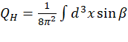 (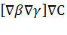)
the equation for Lepton number:
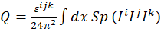
if the vacuum state identifies 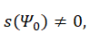then there may be configurations characterized by a chiral invariant.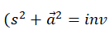), sphere defining as a field diversity that matches the Skyrme model. On the contrary, unless 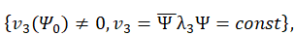 then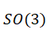 invariant identifies. 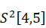 as field diversity that matches the Faddeev model. So, in view of the above, using the analogy with the Skyrme (Faddeev) model, we will choose the following type of spin density Lagrangian for the effective 16-spinor field model:
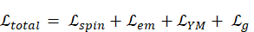
Reference

[1] Witten E. Global Aspects of Current Algebra // Nuclear physics. B223. -1983. - Pp. 422- 432.
[2] Rybakov Yu. P., Topological Solitons in 8-Spinor Mie Electrodynamics, Physics of Atomic Nuclei. 76(10) (2013) Pp. 1284-1288.
[3] Rybakov Yu. P. Problems of the theory of gravitation and elementary particles Atomizdat.1981.Vol.12. Pp. 147.
[4] Yu. P. Rybakov, Phys. At. Nucl. 74. 1073(2011).
[5] AL-Baidhani. Ahmed. K, Sigma model realization in Spinor theory, Vol 8 No 22(2019).

