Synthesis of maleimido-aziridine monomers for 1,3-dipolar polycycloaddition reaction
Sidorova K.S., Lukyanov D.A.
Institute of Chemistry, Saint Petersburg State University, Saint Petersburg, Russian Federation
E-mail: sidorova.ksenia.97@gmail.com
Complementarily bi-functionalized monomers for the reaction of polycycloaddition, which contain dipolarophile fragment on one site of the molecule and 1,3-dipole or its precursor on another site, represent prospective tool for the synthesis of novel macromolecular frameworks. One of the ways of cycloaddition is the reaction of azomethine ylide, generated from aziridine, with dipolarophile. Co-polymers of bis-aziridine and bis-maleimide have been recently reported [1] in our group, M_{w} ranging from 3 to 9 kDa and Ð_{M} being around 1.4. In this work, we describe for the first time the synthesis of bi-finctionalized maleimido-aziridine monomer and its polycycloaddition.
First, aniline 2 was obtained by a two-steps condensation of p-phenylene diamine 1 with maleic anhydride. Next, the aziridine ring was built on compound 2 by a two-steps procedure involving transformation of the amine group to imine followed by Lewis-acid catalyzed nucleophilic addition of diazo ester, which resulted in cis-aziridine 3 (R=Et) as the major product and trans-aziridine 4 as a minor product.
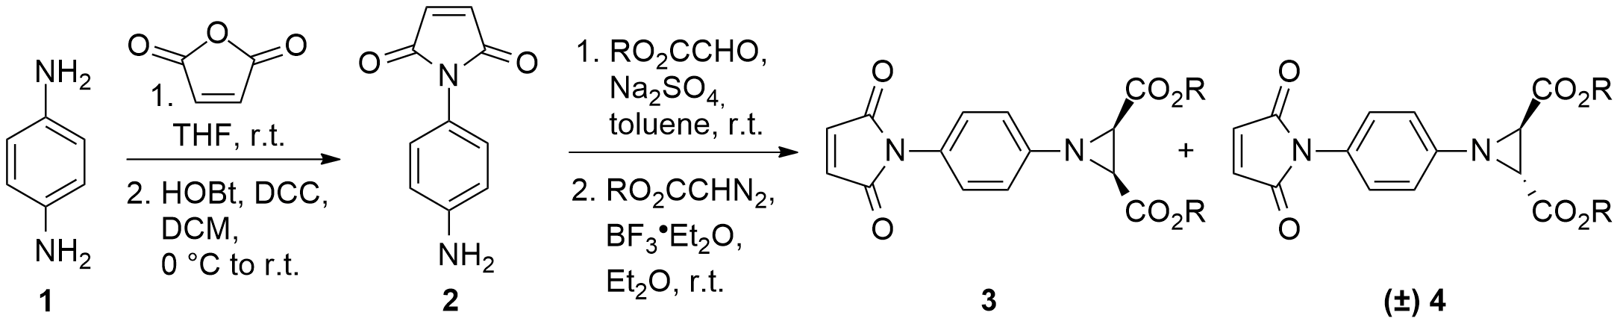
The thermal opening of the aziridine ring in compound 3 proceeded conrotatory giving S-ylide 5, which interacted with activated carbon-carbon bond of the maleimide group, forming tetrahydropyrrolo[3,4-c]pyrrolic core of trans-polycycloadduct 6 with mass-average molecular mass M_{w} = 100 kDa in DMF (Ð_{M} = 2.5) and M_{w} = 175 kDa in ºDCB (Ð_{M} = 4.8) according to GPC.
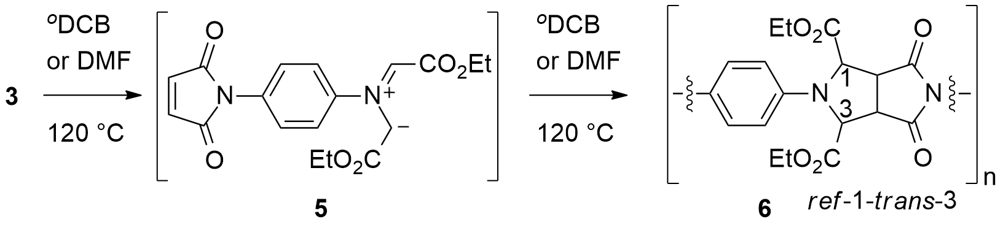
References
- Konev, A.S.; Lukyanov, D.A.; Vlasov, P.S.; Levin, O.V.; Virtsev, A.A.; Kislyakov, I.M.; Khlebnikov, A.F. The Implication of 1,3-Dipolar Cycloaddition of Azomethine Ylides to the Synthesis of Main-Chain Porphyrin Oligomers // Macromol. Chem. Phys. 2014, №6 (215), p. 516‒529.

