New high-efficient catalytic system based on acyclic diaminocarbene palladium complexes for Suzuki cross-coupling reaction
Kashina M.V.
Student
Saint-Petersburg State University, Institute of Chemistry, Saint-Petersburg, Russia
st040562@student.spbu.ru

Complexes with acyclic diaminocarbene ligands (ACDs) have gained prominence as efficient and available alternative to the widely used catalysts based on N-heterocyclic carbenes (NHCs)[1]. In the current study we prepared a series of new palladium-ACDs via the metal-mediated coupling between cis-[PdCl₂(CNXyl] and substituted aminobenzenes provided carbene complexes were isolated in good (80–85 %) yields (complexes 1–6)[2].
Complexes showed high activity (yields up to 99 %, and turnover numbers (TONs) up to 7×10³) in the Suzuki coupling of various aryl bromides with phenylboronic acid. These complexes were compared between each other in the same system. The catalytic procedure runs at 40 °C for 4h in EtOH using K₂CO₃ as a base. No formation of homocoupling products was observed.

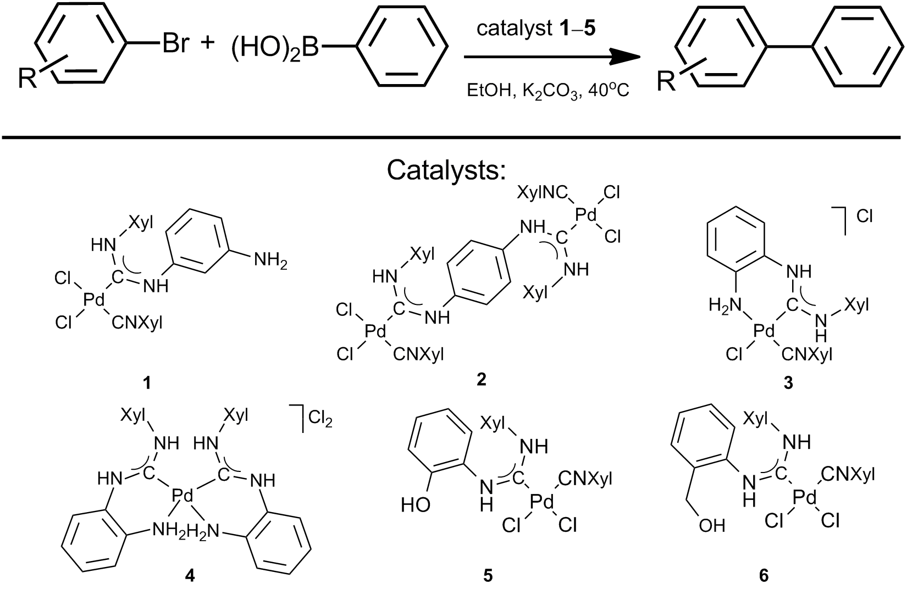

This work has been partially supported by Russian Fund for Basic Research (14-03-00297 А) and Grant of Russian Federation President (МК-7425.2016.3). Author thanks the Center for Magnetic Resonance, Center for X-ray Diffraction Studies, and Center for Chemical Analysis and Materials Research of Saint Petersburg State University and is especially grateful to Kinzhalov M.A. and Katkova S.A.
Literature
- E.A. Valishina, M.F.C. Guedes da Silva, M.A. Kinzhalov, S.A. Timofeeva, T.M. Buslaeva, M. Haukka, A.J.L. Pombeiro, V.P. Boyarskiy, V.Yu. Kukushkin, K.V. Luzyanin. Palladium-ADC complexes as efficient catalysts in copper-free and room temperature Sonogashira coupling // J. Molec. Catalysis. 2014, №395, p. 162-171. 2.
- Mikhail A. Kinzhalov, Svetlana A. Timofeeva, Konstantin V. Luzyanin, Vadim P. Boyarskiy, Anton A. Yakimanskiy, Matti Haukka, Vadim Yu. Kukushkin. Palladium(II)-Mediated Addition of Benzenediamines to Isocyanides: Generation of Three Types of Diaminocarbene Ligands Depending on the Isomeric Structure of the Nucleophile // Organometallics. 2016, №35 (2), p. 218–228.

