Direct Preparation of Nickel Microspheres by Solution Combustion in Ultrasounic – generated Aqueous Aerosols
Trusov G.V. ¹, Tarasov A.B.²,
¹ PhD. student, Institute of Structural Macrokinetics, Russian Academy of Sciences RAS, Chernogolovka, Russia;
² PhD. student, Laboratory of Solid State Ionics, Institute of Problems of Chemical Physics RAS, Chernogolovka, Russia;
E-mail: german.v.trusov@gmail.com
Nickel are most demanded oxide materials for scientific and industrial applications. They are widely used in different forms and modifications as catalysts, magnetic materials, for medical purposes [1]. Although many different approaches are developed to obtain nickel with required properties, any new technique allowing a direct synthesis of single-phase materials still attracts a big attention.
As it has been shown recently, a "solution combustion" technique is one of the most promising candidate for nickel production with controllable properties [2]. The method is based on the usage of highly exothermic self-sustained redox reactions between metal nitrates and organic “fuels”, which are mixed on a molecular level in aqueous solution. Heating of reaction solution leads to water evaporation and formation of a homogeneous reactive mixture, followed by reaction initiation with rapid heat release. The intensive adiabatic self-heating of the environment and appearance of a great amount of gaseous products facilitates the formation of oxide nanocrystalline aggregates. The further development of the method requires to overcome aggregation of resulted nanoparticles.
In present work, we have developed the solution combustion reaction in the individual micron-size droplets of ultrasounic - generated aerosols using an oxidizer and fuel, namely nickel nitrate and glycine. An aqueous reaction solution was nebulized in a preheated to 800ºC quartz tube furnace to produce gray powder depending on preparation temperature and aerosol flow velocity. Phase composition, morphology and optical properties of resulted powders were studied by XRD, SEM, TEM and BET techniques. The magnetic powder obtained at high temperatures or low flow velocity was found to be a well crystalline single phase nickel. Powder consisted of non-aggregated hollow micron - sized spheres with a complex internal structure. All oxide products demonstrated high values of specific surface area.
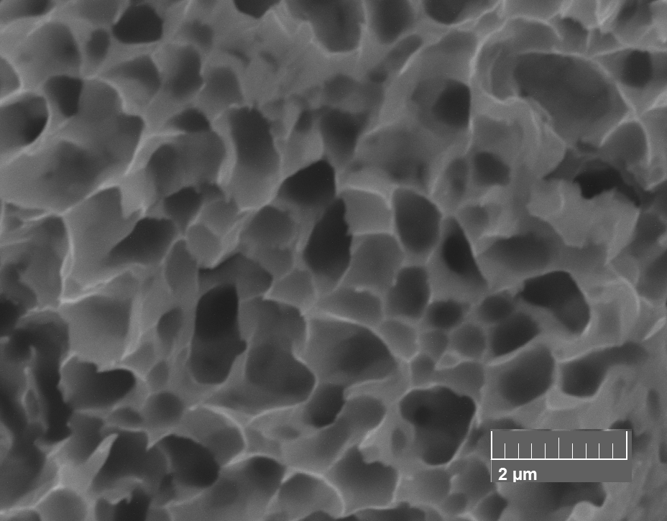
Metallic porous materials on the basis of fine nickel powders are used as an insulating material in the thermal protection systems (TPS) on reusable carrier rocket. Outer cover of the carrier rocket made from such porous materials increases it thermal protection system from the aerodynamic surface heating to the temperatures up to 1000 °C.
To obtain such a new material, synthesized nickel powder sinters to create a honeycomb structure (fig.1) of metal microspheres in which instead of intercrystalline volumetric macropore perform internal cavity of the microspheres, the shell of which are connected by a necks due to the sintering process. Thermal conductivity measurement results shows that metal the samples sintered from the nanothin-walled nickel microspheres have an extremely low thermal conductivity, which proves their use as materials for thermal protection
***Authors express their special thanks to Prof. A.S. Mukasyan for their supervision and fruitful scientific discussions of the work.
References
- S.T. Aruna, A.S. Mukasyan, Combustion synthesis and nanomaterials // Current Opinion in Solid State and Materials Science, 2008, 12 (3), pp. 44-50.
- K. Manukyan, Allison Cross, S. Roslyakov, S. Rouvimov, A. Rogachev, Eduardo E. Wolf, and A. Mukasyan, Solution Combustion Synthesis of Nano-Crystalline Metallic Materials: Mechanistic Studies // J. Phys. Chem. C, 2013, 117 (46), pp. 24417–24427.

