Interrelation of liabilities and revenue of the company “LUKOIL”
Виктория Игоревна Самойлова
Бакалавр
Финансовый университет при Правительстве РФ, 3 курс, Международный Финансовый Факультет, Москва, Россия
E-mail: viktoriia.samoilova@mail.ru
OAO LUKOIL is one of the largest oil and gas companies in the world. LUKOIL is a major international vertically-integrated oil & gas company, accounting for 2.1% of global output of crude oil and about 1% of proved hydrocarbon reserves. LUKOIL is implementing oil & gas exploration and production projects in 13 countries. The Company is a leader on Russian and international markets in its core business. The mission of the company is to harness natural energy resources for human benefit.
Revenues - the increase of the economic benefits as a result of receipt of assets and repayment of liabilities, leading to an increase in capital of the organization. Revenue is important because it is the money that comes into the business and the business will be able to use it on any possible equipment or resources that are needed. Total Liabilities represents the sum of all monetary obligations of the company and the requirements that are listed in the assets of creditors.
In order to carry out the analysis, it is necessary to prepare the statistical data of OAO LUKOIL for the period from 2002 till 2013 for studying the interrelation of financial indicators of the company. All data was taken from the OAO LUKOIL Financial Reports, which are located on the LUKOIL website.
In this work the investigation will be taken a step further in those cases for which there is a hypothesize that one variable depends on another.
During the research, there was observed several indicators interrelation of revenue and total liabilities. By using the formula, the correlation coefficients were found. The correlation coefficient of revenue and total liabilities is equal to 0,95. There is moderate strong positive linear relationship. This dependence can be seen in Figure 1, constructed with the use of data from the LUKOIL website.
Graph 1
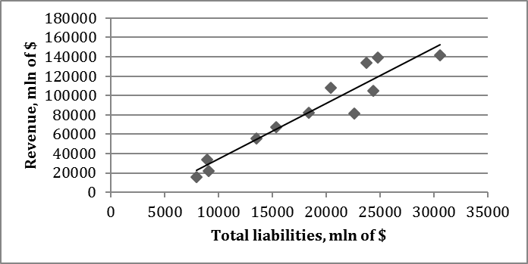
Source: constructed by the author of the article
The development of an econometric model begins with the specification of this model, i.e. description of the observed object with the further description of it’s functioning process by эконометр методы. It is important to formulate and identify the problem, given to the investigator, also to identify all the significant factors and patterns, which characterize the system’s functioning.
According to the results of the regression analysis of the estimated econometric model specification has the form:

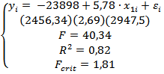
Where x- dependent variable revenue, y-total liabilities, - random variable characterizing the deviation of the actual value from the theoretical efficient feature found according the regression equation, - coefficient of determination, F - the value of Fisher test, in round brackets there are the error estimations of the coefficients.
The value of is 0,82. So, regression line fits the observations exactly, there is apparent relationship between the values of Y and X in the sample. Any increase in total liabilities will lead to increase in revenue.
The F-statistic for the goodness of fit of a regression is written as the explained sum of squares, per explanatory variable, divided by the residual sum of squares, per degree of freedom remaining: F=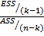, where n – number of observations, k – number of parameters in the regression equation (intercept and k-1 slope coefficients). If α=0,01, =10,04. If α=0,05, =4,96. If α=0,1, =3,29. F = 40,34. In all cases F > , the “Explanation” of Y is better than is likely to have arisen by chance. In this model is not random and the quality of our model is high.
A T-test is any statistical hypothesis test in which the test statistic follows a Student's t distribution if the null hypothesis is supported. It is most commonly applied when the test statistic would follow a normal distribution if the value of a scaling term in the test statistic were known. When the scaling term is unknown and is replaced by an estimate based on the data, the test statistic (under certain conditions) follows a Student's t distribution. If α=0,01, =1,09 is less than =3,17. So, it is not significant. =6,35 > 3,17. It is significant. If α=0,05, =1,09 is less than =2,23. So, it is not significant. =6,35 > 2,23. It is significant. If α=0,1, =1,09 is less than =1,81. So, it is not significant. =6,35 > 1,81. It is significant.
So, we can make a conclusion that is not significant and is significant.
In all cases F > , the “Explanation” of Y is better than is likely to have arisen by chance. In this model is not random and the quality of our model is high.
By results of check of the Gauss Markov theorem the residuals are homoscedastic. The model is adequate and can be used for forecasting.
Thus, an adequate model was developed. It can be said that it is suitable for predicting the future dependence of total liabilities and total revenue of the company as an increase of 1 million in liabilities will lead to the increase of revenue in 5,780,000 and it is definitely seen from the research that there is strong linear dependence between this two coefficients.
Литература:
- http://www.lukoil.ru/static_6_5id_218_.html
- Трегуб А.В., Трегуб И.В. Методика прогнозирования показателей стохастических экономических систем // Вестник Московского государственного университета леса, Лесной вестник. 2008. № 2. С. 144-151.
- Трегуб А.В., Трегуб И.В. Методика прогнозирования основных показателей развития отраслей российской экономики // Вестник Московского государственного университета леса, Лесной вестник. 2014. № 4 (103). С. 231-236.
- Кузнецов В.Д., Трегуб И.В. Математическое моделирование динамики экономических показателей (на примере выручки IT компании) // Современные проблемы науки и образования. 2013. № 6. С. 424.

http://www.lukoil.ru/static_6_5id_218_.html

