Multimodal Metaphors in Francis Quarles’ Hieroglyphics of the Life of Man

Алтухова Ольга Игоревна

Студентка Московского государственного университета

имени М. В. Ломоносова, Москва, Россия

Multimodal discourse analysis is now regarded as a burgeoning interdisciplinary field, though the approach itself was first suggested in 1959 by R. Jakobson, who singled out three types of translation: interlingustic, intralinguistic and intersemiotic - ‘an interpretation of verbal signs by means of signs of nonverbal sign systems’ [Jakobson 1959]. Since then, the interest of the academic community has gradually shifted from mere intersemiotic translation to the mutual integration of the verbal and the nonverbal, so that discovering the way different semiotic resources (or ‘modes’) complement each other in order to convey a certain message has become a popular theme in linguistic and cognitive studies. Pioneering works of such scholars as Gunther Kress, Charles Forceville et al. paved the way to further research in the field.
The present paper discusses multimodal manifestations of conceptual metaphors in verbal and nonverbal art. The study of multimodal ‘events’ actually stems from the distinction between the conceptual (i.e. mental) and the linguistic levels, which was drawn by the American cognitive linguist George Lakoff. A conceptual metaphor, in Lakoff’s terms, presupposes a correspondence (mapping) between a source domain (=conceptual domain used to explain an abstract idea) and a target domain (=the domain to be explained) [Lakoff, Johnson: 246]. Consequently, while this framework remains intact by definition, the linguistic mode of expression may give way to - or even be combined with - a non-linguistic one: in the latter case a multimodal metaphor emerges, whose target and source are each represented exclusively or predominantly in different modes [Forceville, Urios-Aparisi: 430]. It is possible to go beyond mere structural analysis of such metaphors in order to explore the role of artistic creativity in an intersemiotic blend. To this end, the notions of extension (adding new slots), elaboration (filling the existing ones in an unconventional way), questioning (showing the limitations of conventional mappings) and composing (using a number of metaphors simultaneously), which were introduced by G.Lakoff and M. Turner [Lakoff, Turner: 67-71], can be successfully applied.
An emblem book may be considered a prototypical multimodal ensemble where the visual and verbal modes are essentially inseparable. One of the leading genres of the Baroque era in continental Europe, in Britain it was represented rather poorly, gaining in popularity only with the arrival of Emblems, divine and moral, together with Hieroglyphicks of the life of man by Francis Quarles (1634-38). The Emblems preserve the tripartite structure characteristic of most Baroque books: a motto (lemma/inscriptio), an image (pictura) and an epigram (subscriptio). After the analysis of the 15 emblems a number of conceptual metaphors were discovered, including LIFE IS A DAY/A YEAR/A JOURNEY/A PLAY/A DEBT/A CLOCK, DEATH IS NIGHT/DARKNESS//REST/ADVERSARY, PEOPLE ARE PLANTS/BUILDINGS and LOVE IS FIRE. Expressive resources of specific modes (colour intensity, framing, focal area for the visual; rhythm and meter for the verbal, etc.) facilitate cross-modal integration, which can be seen, for instance, in Emblem IX:

Visual component | Verbal component | Conceptual basis
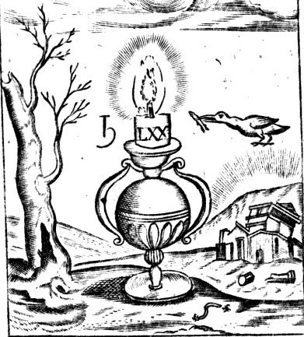 | - That glorious sun <…> Is now ev'n ravish'd from our darken'd eyes: /  - That sturdy castle <…> Lies now a mon'ment of her own disguise: /  - That blazing taper <…> scarce owns the name of snuff. | LIFE IS A DAY  DEATH IS NIGHT  DEATH IS DARKNESS  PEOPLE ARE BUILDINGS  LIFE IS LIGHT
Apart from the thematic connection between the visual and the verbal, the two complementary modes share the same rhythm, rendered by anaphora and syntactic parallelism and by symmetrical composition and regular alternation of images with the negative space respectively. Additionally, the notion of modal affordance is discussed in the paper – that is, the possibility of expressing certain meanings with a particular mode due to a set of social, cultural and historical practices as well as the properties of the medium itself. Thus, monochrome palette suits the introduction of conceptual metaphors like LIFE IS LIGHT / DEATH IS DARKNESS, prompting the author to elaborate them meticulously at the expense of unrelated metaphors (such as, for example, LIFE IS A JOURNEY – a metaphor hinted at visually through the use of a particular type of background, yet less frequently supported by the subscriptio).
The use of cognitive approach in analyzing XVII-century English poetry provides an insight into the structure of verbo-visual texts as multimodal phenomena. Apart from its practical importance for preparing digital editions of emblem books and arranging pictorial collections, it helps to single out patterns of intersemiotic integration which are typical of a particular historical period.
References
Forceville C., Urios-Aparisi E. Multimodal Metaphor. Berlin, 2009.
Jakobson R. On Linguistic Aspects of Translation // http://culturalstudiesnow.blogspot.ru/2011/10/roman-jakobson-on-linguistic-aspects-of.html
Lakoff G., Johnson M. Metaphors We Live By. Chicago, 1980.
Lakoff G., Turner M. More than Cool Reason: A Field Guide to Poetic Metaphor. Chicago, 1989.

